Create a Server for Expense REST API
The prerequisite for HTTP programming is a basic understanding of the HTTP protocol and REST API techniques. HTTP programming involves two parts: the server and the client. Angular provides support for creating client-side applications, while Express (a popular web framework) provides support for creating server-side applications.

Let us create an Expense Rest API using the express framework and then access it from our Expense Manager application using the Angular HttpClient service.
- Create a new application express-rest-api. Open with VS Code. Start command window with admin right. Run the following commands:
- cd\
- md express-rest-api
- cd express-rest-api
- code .
- In the terminal, run npm init with following settings:
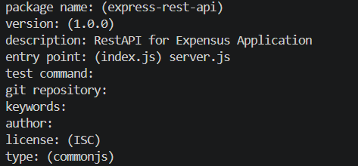
- Install express, SQLite, andcorsmodules using the command
npm install express sqlite3 cors
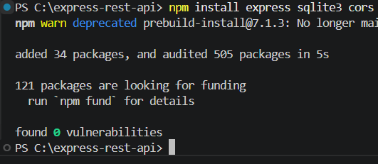
Here, we create a basic CURD rest API to select, insert, update, and delete expense entries.

- Add a new server.js file at project root
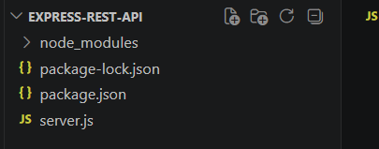
- Prepare the code in server.js
var express = require("express")
var cors = require('cors')

var sqlite3 = require('sqlite3').verbose()
const DBSOURCE = "expensedb.sqlite"

let db = new sqlite3.Database(DBSOURCE, (err) => {
if (err) {
console.error(err.message)
throw err
}else{
console.log('Connected to the SQLite database.')
db.run(`CREATE TABLE expense (
id INTEGER PRIMARY KEY AUTOINCREMENT,
item text,
amount real,
category text,
location text,
spendOn text,
createdOn text
)`,
(err) => {
if (err) {
console.log(err);
}else{
var insert = 'INSERT INTO expense (item, amount, category, location, spendOn, createdOn) VALUES (?,?,?,?,?,?)'

db.run(insert, ['Pizza', 10, 'Food', 'KFC', '2020-05-26 10:10', '2020-05-26 10:10'])
db.run(insert, ['Pizza', 9, 'Food', 'Mcdonald', '2020-05-28 11:10', '2020-05-28 11:10'])
db.run(insert, ['Pizza', 12, 'Food', 'Mcdonald', '2020-05-29 09:22', '2020-05-29 09:22'])
db.run(insert, ['Pizza', 15, 'Food', 'KFC', '2020-06-06 16:18', '2020-06-06 16:18'])
db.run(insert, ['Pizza', 14, 'Food', 'Mcdonald', '2020-06-01 18:14', '2020-05-01 18:14'])
}
}
);
}
});

var app = express()
app.use(cors());

var bodyParser = require("body-parser");
app.use(bodyParser.urlencoded({ extended: false }));
app.use(bodyParser.json());

var HTTP_PORT = 8000
app.listen(HTTP_PORT, () => {
console.log("Server running on port %PORT%".replace("%PORT%",HTTP_PORT))
});

app.get("/", (req, res, next) => {
res.json({"message":"Ok"})
});

app.get("/api/expense", (req, res, next) => {
var sql = "select * from expense"
var params = []

db.all(sql, params, (err, rows) => {
if (err) {
res.status(400).json({"error":err.message});
return;
}
res.json(rows)
});

});

app.get("/api/jsonp/expense", (req, res, next) => {
var sql = "select * from expense"
var params = []
db.all(sql, params, (err, rows) => {
if (err) {
res.status(400).json({ "error": err.message });
return;
}
res.jsonp(rows)
});

});

app.get("/api/expense/:id", (req, res, next) => {
var sql = "select * from expense where id = ?"
var params = [req.params.id]
db.get(sql, params, (err, row) => {
if (err) {
res.status(400).json({"error":err.message});
return;
}
res.json(row)
});
});

app.post("/api/expense/", (req, res, next) => {
var errors=[]
if (!req.body.item){
errors.push("No item specified");
}
var data = {
item : req.body.item,
amount: req.body.amount,
category: req.body.category,
location : req.body.location,
spendOn: req.body.spendOn,
createdOn: req.body.createdOn,
}
var sql = 'INSERT INTO expense (item, amount, category, location, spendOn, createdOn) VALUES (?,?,?,?,?,?)'
var params =[data.item, data.amount, data.category, data.location, data.spendOn, data.createdOn]
db.run(sql, params, function (err, result) {
if (err){
res.status(400).json({"error": err.message})
return;
}
data.id = this.lastID;
res.json(data);
});
})

app.put("/api/expense/:id", (req, res, next) => {
var data = {
item : req.body.item,
amount: req.body.amount,
category: req.body.category,
location : req.body.location,
spendOn: req.body.spendOn
}
db.run(
`UPDATE expense SET
item = ?,

amount = ?,
category = ?,
location = ?,

spendOn = ?
WHERE id = ?`,
[data.item, data.amount, data.category, data.location,data.spendOn, req.params.id],
function (err, result) {
if (err){
console.log(err);
res.status(400).json({"error": res.message})
return;
}
res.json(data)
});
})

app.delete("/api/expense/:id", (req, res, next) => {
db.run(
'DELETE FROM expense WHERE id = ?',
req.params.id,
function (err, result) {
if (err){
res.status(400).json({"error": res.message})
return;
}
res.json({"message":"deleted", changes: this.changes})
});
})

app.use(function(req, res){
res.status(404);
});
- Save all files
- Run command npm run start in Terminal
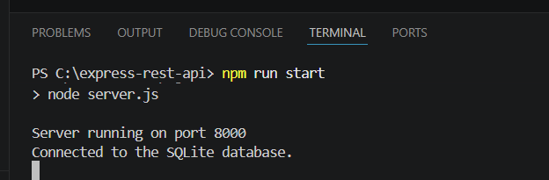
- Open a browser, enter http://localhost:8000/ and press enter. You will see below response:
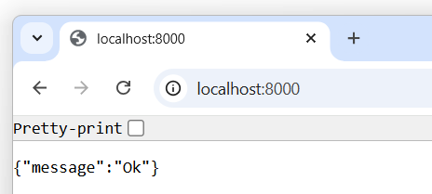
- Change the URL to http://localhost:8000/api/expense, and you will see all the expense entries in JSON format.
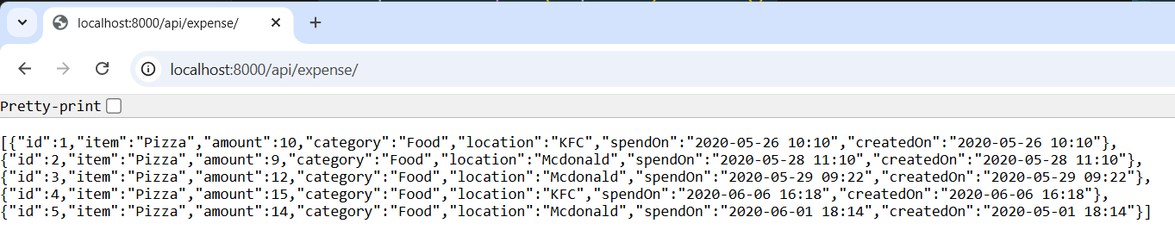
- Leave this server remain running.

Note: In case you shutdown the server, delete the sqlite database file expensedb.sqlite before restart again.

